Can I charge the 12V battery using the jump start points under the passenger frunk cover? YES
Connect directly to battery terminals? Can connect to directly to positive terminal. Cannot connect directly to negative battery terminal. Must connect downstream of BMS sensor, see below for locations.
Do I have to disconnect negative cable if charging at battery? NO
If not using the jump point under the passenger frunk, remove the battery access panel at the back of the frunk and connect your charging clamps per this pic:
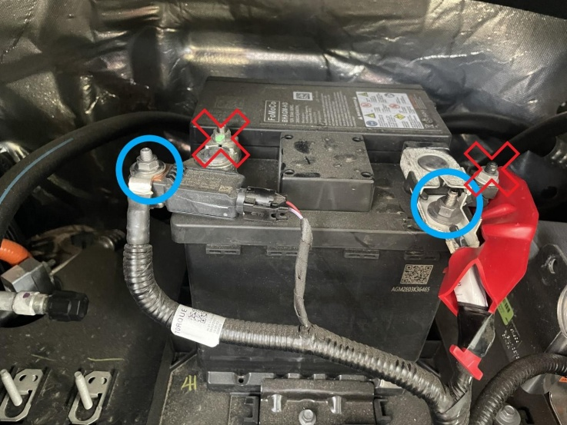
On the left the blue circle shows a lug that is downstream of the BMS sensor. You can connect your negative clamp here.
On the right, pull back the red plastic cover and connect your positive clamp to point circled in blue. Do not connect to the points with a red X.
There is an alternate Negative/Ground location shown in the Police Modifier Bulletin. I did not check the thread size, possibly a M6 as well. Here is a pic from that:


